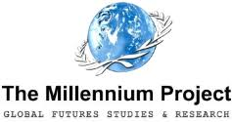

Relationship between the Millennium Project
15 Global Challenges (MP15GC)
and
the 17 United Nations Sustainable Development Goals (UN17SDG)

Jerome Glenn
Elisabeth Florescu
Héctor Casanueva

February, 2020

I

THE 15 MILLENNIUM PROJECT GLOBAL CHALLENGES

The 15 Global Challenges assessed by The Millennium Project provide a framework for thinking about the future of the world as a whole. They have been identified and are systematically updated through ongoing environmental scanning, periodic Delphi studies, expert opinions, and interviews since 1996. They represent a cumulative and distilled range of views from over 4,000 participants from around the world assessing the global and local prospects for humanity.
Each of the MP15GCs is presented with a description, a range of views and actions to address it, enriched with regional views and progress assessments, and further references. A short overview is published in the periodical State of the Future reports, while continuous updates and details are available on the Global Futures Intelligence System website: https://themp.org.
The MP15GCs are transnational in nature and transinstitutional in solution. They cannot be addressed by any government or institution acting alone. They require collaborative action among governments, international organizations, corporations, universities, NGOs, and creative individuals. Although listed in sequence, Challenge 1 on sustainable development and climate change is no more or less important than Challenge 15 on global ethics. There is greater consensus about the global situation as expressed in these Challenges and the actions to address them than is evident in the news media.
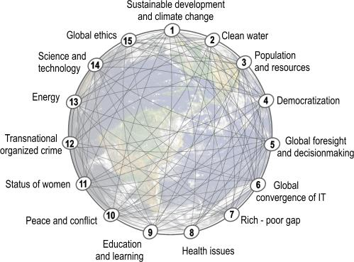

II
THE UNITED NATIONS 17 SUSTAINABLE DEVELOPMENT GOALS

The Sustainable Development Goals are a universal call to action to end poverty, protect the planet and improve the lives and prospects of everyone, everywhere. The 17 Goals were adopted by all UN Member States in 2015, as part of the 2030 Agenda for Sustainable Development which set out a 15-year plan to achieve the Goals.
They are the blueprint to achieve a better and more sustainable future for all. They address the global challenges we face, including those related to poverty, inequality, climate change, environmental degradation, peace and justice.
In September 2019, the UN Secretary-General called on all sectors of society to mobilize for a decade of action on three levels: global action to secure greater leadership, more resources and smarter solutions for the Sustainable Development Goals; local action embedding the needed transitions in the policies, budgets, institutions and regulatory frameworks of governments, cities and local authorities; and people action, including by youth, civil society, the media, the private sector, unions, academia and other stakeholders, to generate an unstoppable movement pushing for the required transformations.
The 17 Goals are all interconnected, and in order to leave no one behind, it is important that we achieve them all by 2030.

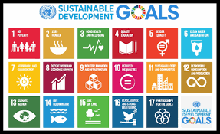

III
RELATIONSHIP BETWEEN MP15GC AND UN17SDG

MP15GC began 1996-97, which were created 4 years before the UN’s Millennium Development Goals (first UN set of 15 year goals; the SDGs are the second set of goals 2015-2030).
They were given as input for the UN Millennium Summit (2000) via a special publication (Global Challenges at the Millennium) sponsored by the State of the World Forum. The report was distributed to UN Missions in New York, Embassies in Washington, DC., and UN Summit Side meeting of several hundred participants in the State of the World Forum, September 2000.
The scope and spectrum of the MP15GCs and the UN17SDGs are different. While the UN17SDGs seek to focus attention, political will and funds towards achieving some targets by 2030, the MP15GCs are ongoing and long-range. They are updated with improved insights and data on an ongoing basis, providing a framework for understanding global change. They include trends, future possibilities, strategies, and some goals. Fractal in that each can be understood and addressed locally, nationally, and internationally.
The UN17SDGs, as well as the MP15GCs are complex systems with all elements interdependent; improving one helps the others and vice-versa. The two systems are also interrelated among themselves; progress (or regress) on the elements of one impacting the elements of the other.
It is important to highlight that addressing the MP15GCs helps progress on all the UN17SDGs. There is no MPGC that would not be directly related and if positively addressed would be helping progress on at least one UNSDG—as reflected in the table below—and vice-versa, progress on any of the UNSDGs helps address several MPGCs.
The fact that some UNSDGs are directly impacted by more or less MPGCs does not necessarily reflect on the complexity of the respective UNSDG. However, it can help with policy coherence design. Obviously, the MPGC on Sustainable Development and climate change is the one impacting the most UNSDGs, since they are all related to sustainable development.
Focusing on one, or a small group of UN17SDGs and/or MP15GCs, could be counterproductive to the system as a whole and hence, to a real sustainable development. Reporting should be continuously made by all organizations on all the UN17SDGs, even if not directly related to their specific area or work.
The conclusion is that a systemic and systematic assessment of the MP15GCs helps to understand and address progress on the UN17SDGs, as well as to identify actions and actors and inter-linkages that could help progress—e.g. address UNSDG Nº17 on building policy coherence, which is extremely difficult and the focus of many organizations (the OECD even having a dedicate program for it.)
It is important to note that no direct link among a UNSDG and some MPGCs does not mean no impact or no link at all, since progress on at least one of the directly linked MPGCs depends on progress on many other MPGCs, therefore impacting the respective UNSDG which might not have been directly linked.
The MP15GCs go beyond the UN17SDG, as long-term global challenges for humanity. Therefore, they represent a valuable permanent input for multilateral political decisions.
The following table and graph show the most direct relations among the UN17SDGs and the MP15GCs. The graphic representation is very busy, helping to make the point of the systemic and very complex relationships among theitems. The table is simpler and hence, easier to follow.

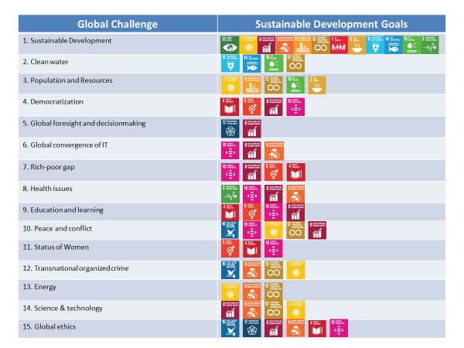

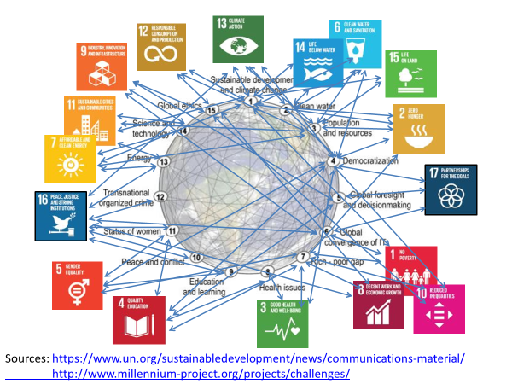

THE MILLENNIUM PROJECT
The Millennium Project is a global participatory think tank established in 1996 under the American Council for the United Nations University. It became independent NGO in 2009 .The Project was initiated by the Smithsonian Institution, The Futures Group International, and the United Nations University (UNU). It was created through a three-year feasibility study funded by the U.S. EPA, UNDP, and UNESCO, in which participated over 200 futurists and scholars from about 50 countries. TMP has grown to 65 Nodes around the world (an MP Node is a group of institutions and individuals that connect local and global perspectives)
Purpose:
Improve humanity’s prospects for building a better future.
Mission:

Improve thinking about the future and make that thinking available through a variety of media for feedback to accumulate wisdom about the future for better decisions today.

Vision:
A global foresight network of Nodes, information, and software, building a global collective intelligence system recognized for its ability to improve prospects for humanity. A think tank on behalf of humanity, not on behalf of a government, or an issue, or an ideology, but on behalf of building a better future for all of us.
Key Outputs:
Global Futures Intelligence System
State of the Future reports
State of the Future Index
Futures Research Methodology 3.0
Special global futures research
Training, Conferences, Lectures

Board of Directors
Jerome Glenn,, Chair, CEO, Co-Founder
Concepcion Olavarrieta, Vice-Chair
Theodore Gordon, Senior Fellow, Co-Founder
Charles Perrottet, Secretary
Elizabeth Florescu, Treasurer
Youngsook Park, Member
http://www.millennium-project.org/

THE MILLENNIUM PROJECT
4421 Garrison Street, N.W. Washington, D.C. 20016-4055
+1 (202) 686-5179
info@millennium-project.org
Newsletter subscription: http://eepurl.com/JXt4n

http://www.millennium-project.org/
https://www.un.org/sustainabledevelopment/sustainable-development-goals/

